
Michigan Coalition for Human Rights
announces its
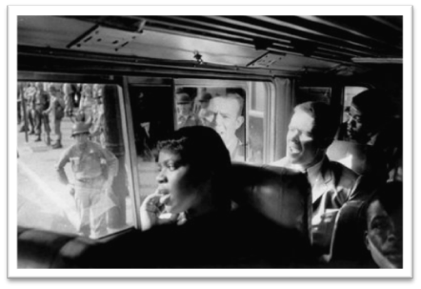
2020 Freedom Tour
June 19th – June 30th
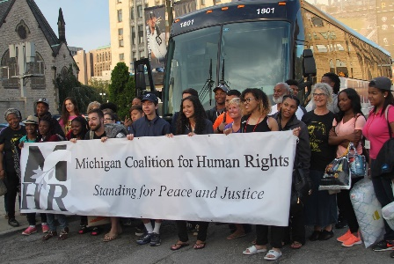

Walk the history of the civil rights movement,
Explore the topics of climate justice and indigenous sovereignty and build community with high school students in metropolitan Detroit.

KENTUCKY, GEORGIA, ALABAMA, MISSISSIPPI, TENNESSEE

We will be taking high school students from metro-Detroit to Berea College in Kentucky, the King's Center in Atlanta, GA, the Birmingham Civil Rights Institute, the Southern Poverty Law Center in Alabama, the Viola Liuzzo Commemorative Site, Choctaw reservation in Mississippi… and more.

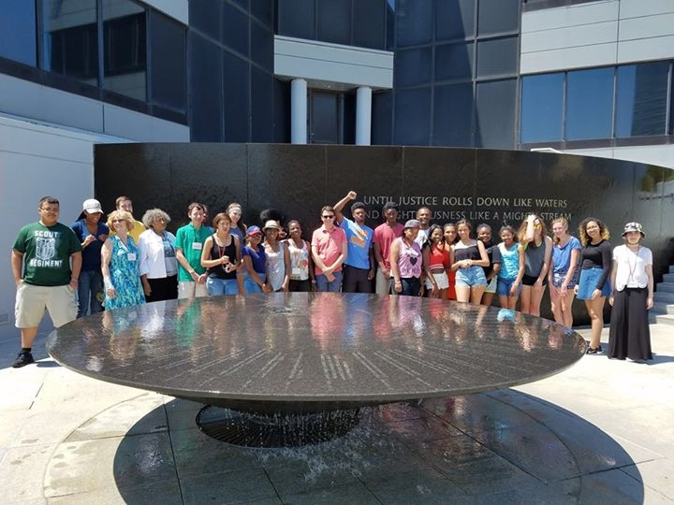

Interested in applying? Applications due by February 14, 2020
Visit www.mchr.org or find us on Facebook.

Questions? Contact Chantelle Yancy at MCHRFreedomTour@gmail.com or 248-238-9808

Michigan Coalition for Human Rights (MCHR) promotes awareness of, commitment to and advocacy for human rights and the environmental rights of planet Earth through education, community organization and action. MCHR opposes forces that suppress human dignity, and justice — locally and around the world.
 Michigan Coalition for Human Rights 
Freedom Tour
INFORMATION SHEET
What is MCHR?
The Michigan Coalition for Human Rights (MCHR) promotes awareness of, commitment to and advocacy for human rights and the environmental rights of planet Earth through education, community organization and action. MCHR opposes forces that suppress human dignity, and justice — locally and around the world.

What is the Freedom Tour?
The Freedom Tour is an educational trip with high school students from metro-Detroit learning and walking the history of the civil rights movement. It will be an opportunity to learn deeply the history and engage the questions of what it means for us today and in Detroit. The students participating will work together for the six months prior fundraising, learning the history here in Detroit, being trained in nonviolence, and building community.

When: Friday, June 19th - Tuesday, June 30th

Where: Berea, KY, Atlanta, GA, Selma, Montgomery and Birmingham, AL, Jackson and Meridian, MS, Henning and Memphis, TN

Before the Trip
Cost: The cost of the trip includes transportation, housing, food, and programming. A majority of the cost will be fundraised by MCHR and the students, we ask that families contribute $300 towards the trip.

Fundraising: Each student will cost approximately $1500. We are committed as an organization to helping raise most of the funds. We will also ask the students to work together in the spring on fundraising projects to help raise the cost of the trip.

Training and Preparation: As part of the program, we ask that students participate in pre-trip planning, training, and fundraising activities. Students will be required to attend pre-trip trainings and retreats. Active involvement and participation on the tour is mandatory as well. Background checks are required for students who are 18 years of age or older.

On the Trip
Transportation/Housing: The transportation will be provided by charter bus. In each city, the group will be staying in institutional housing including university dorms and hotels.

Meals: Meals and snacks are covered in the cost of the trip and will be planned within the itinerary.

Mentors: The students will be accompanied by chaperones at a 3 to 1 ratio. Chaperones will include college mentors as well as board members and staff from MCHR. Background checks and trainings are required.

Application Process: Applications are due by February 14, 2020. Students will be notified in February.
Please mail your application to Gratiot, Detroit, MI 48213 or email it to MCHRFreedomTour@gmail.com.
Michigan Coalition for Human Rights
Freedom Tour
APPLICATION

Student Name ________________________________________________________________________

Address______________________________________________________________________________

Home Phone ______________________________ Cell Phone __________________________________

Email_____________________________________ Other _____________________________________

School ______________________________________________ Grade ___________ Age____________

Parent/Guardian Name(s) ______________________________________________________________

Home Phone _______________________________ Cell Phone _________________________________

Email_____________________________________ Other ______________________________________

Do you need any accommodations? (dietary, religious, ability needs, etc., please indicate these needs on the
back of this application)

Reflection Questions
Please write brief reflections to the following questions on a separate sheet of paper and return them with the application.

1. Why do you want to participate in the Freedom Tour 2020?

2. How do you understand your own identity and how it will be touched by this experience?
(ex. Race, class, gender, sexual orientation)

3. How will you bring back what you learned to the city of Detroit?

Please sign below if you agree to the following:
I AGREE to participate in the Freedom Tour in a spirit of nonviolence, learning, and community.
I AGREE to engage with the pre-trip activities and trainings with my fellow participants.
I AGREE to help with fundraising, so we all work together to raise the funds we need.

________________________________________ ____________________________
Student Signature Date

_________________________________________ ____________________________
Parent/Guardian Signature Date

Mail in this application by February 14, 2020. Questions? Please email us at: MCHRFreedomTour@gmail.com

